LaCie 24TB d2 Professional USB-C 3.2 Gen 2 External Hard

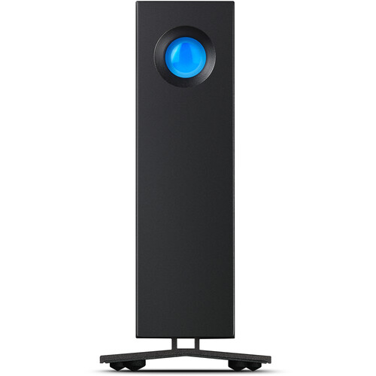

**Key Features**

* **Massive 24TB Storage**: The drive provides an impressive 24 terabytes of storage space, allowing users to store and back up large files, such as high-resolution videos, large databases, and more.
* **USB-C 3.2 Gen 2 Compatibility**: The drive features USB-C (USB 3.2 Gen 2) connectivity, offering fast data transfer rates of up to 10Gbps, ensuring smooth and fast access to large files.
* **High-Speed Performance**: Thanks to its 7200 RPM hard disk and advanced cache management, the drive delivers quick read/write speeds, making it suitable for tasks such as video editing and heavy file transfers.
* **Hardware Encryption**: The drive includes built-in hardware encryption for data protection, ensuring that sensitive files are kept safe from unauthorized access.

**Data Protection and Security**

* **Hardware Encryption**: The built-in hardware encryption allows users to safeguard their sensitive data, offering a higher level of security compared to software encryption solutions.

**Warranty and Support**

* **Limited 5-Year Warranty**: The LaCie 24TB d2 comes with a 5-year warranty, ensuring peace of mind for professionals relying on the drive for critical data storage.